
G
HY/EC/1220A 18/11/2020
HALF YEARLY EXAMINATION (2020-21)
Subject: ECONOMICS (Answer Key)  Grade: XII |  | Max. Marks: 80  Time:
Macro - Section A
 | c.
2. | c.
3. | False. The value of APC has no relationship with MPC. Either APC + APS = 1 or MPC + MPS = 1
4. | b.
5. | a.
6. | c.
7. | Annual depreciation of the capital good = value of the fixed asset / life span. 15/ 5 = Rs 3 lakhs  OR  The household play dual role in two sector economy:  (a) HH provide factor services to the firms  (b) They spend their income on goods and services produced by firms. (1/2+1/2=1)
8. | - GDP and GNP will be equal when the ‘net factor income from abroad’ is zero.  - Value of output is equal to value added if there are no intermediate costs
9. | 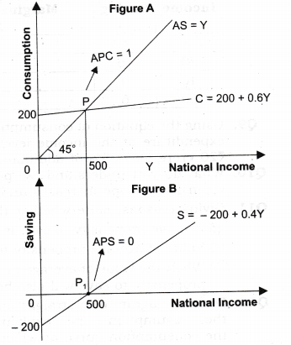  (1/2 + ½ =1))
10. | Fiscal Deficit = PD + IP. FD = Rs10,000+ Rs 1600 = Rs 11,600 crores (1mrk)
11. | Capital, Revenue , Capital  (1mark each with reason) |  | 3
12. | The deficit in a government budget can be reduced by the following step:  - Taxes should be increased. Government can make a plan for rising direct taxes to increase its receipt. It can also be raised by increasing rates of taxes or by imposing new taxes. Direct taxes are more productive because its cost of collection is quite lower.  - Reduction in Government Expenditures: It can be done through making government activities more efficient through better planning of programmes and better administration.  - Disinvestment – The government can raise its receipts through the sale of shares in PSUs (Public Sector Undertaking).  (1x3=3marks. Students can give any other relevant reason)  OR  Equitable distribution of income and wealth is a sign of social justice which is the principal objective of any welfare state as in India. The government uses budgetary instruments of taxation and subsidies with a view to improving the distribution of income and wealth in the economy. Distribution of income is impacted largely by way of ‘progressive taxation policy’. It implies greater tax burden on the rich and lesser on the poor. In fact, those with very low incomes are exempted from the payment of the tax. Those who are absolutely poor are offered goods through Public Distribution System at the subsidised rates. (3marks) |  |  | 3
13. | Value Added by Firm A = (iv) + [(vii) – (vi)] – (i) – (iii)  = 120 + [30 – 45] – 40 – 60  = Rs 5 Lakhs. (2marks)  Value Added by Firm B = (ii) + [(ix) – (viii)] – (x)  = 100 + [30 – 40] – 60  = Rs 30 Lakhs. (2marks)  OR  - Yes, It is a part of Government final consumption expenditure and it adds to flow of services.  - Yes, as it is payment for use of capital.  - No, as it does not add to flow of goods & services or capital gain.  - It should not be included in NI because public debt is a loan taken on to meet consumption expenditure by the government.  (1x4=4marks) |  |  | 4
14. | 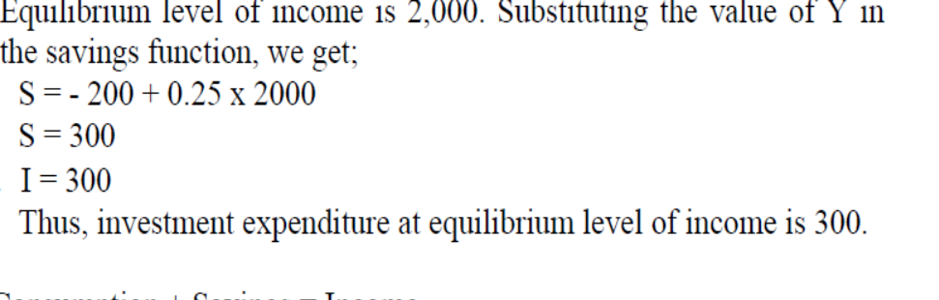 (1mark)  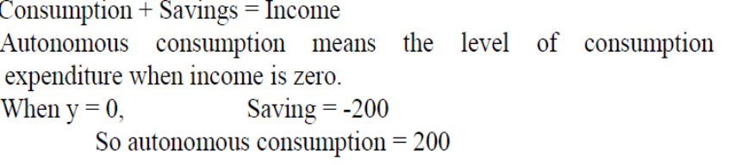 (1mark)  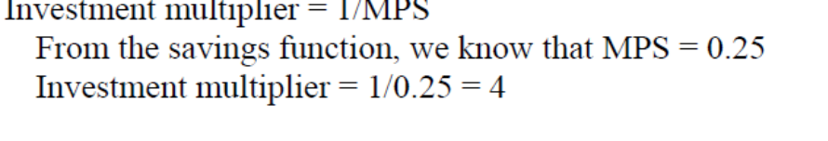 (1 mark)  (b) True, change can never be negative. (1mark) |  |  | 4
15. | - False, if incurred on the creation of assets, capital expenditure increases capital stock of the government.  - False, it is non-development expenditure because it does not directly add to the flow of goods and services in the economy.  - True, because it create assets for the central government.  - False, it is an indirect tax because its burden can be shifted on to the other person.  (1x4=4marks) |  |  | 4
16. | Income Method:  W&S + Rent + SSS +Royalty + Profit +Interest +MI+NFIA+NIT= Rs1080 lakhs  Expenditure Method:  PCE+GBFI+GPI+GRI+ Inventory investment+ Govt.purchases + X-M+NFIA-CFC = Rs1080  (3 marks each-- 1 marks for formula, 1.5 marks for working & ½ mark for final answer) |  |  | 6
17. | Economy is in equilibrium when S= I. Disequilibrium situation arises either when S< I or when S>I. Planned savings are greater than planned investment: If S>I overall expenditure in the economy would remain lower than what is required to buy the planned output. Some output would remain unsold, producers will have undesired stocks. To clear the stock producers will now plan lesser output in the next time period, this means lesser employment, income & savings in the economy. The process continues till S= I .Planned savings are less than planned investment: consequences and diagram  (2+2 marks for explanation.2 for diagram with explanation)  OR  Inflationary Gap is the excess of AD over and above its level required to maintain full employment equilibrium in the economy. Inflationary Gap is measured as the difference between AD beyond full employment and AD at full employment. Inflationary Gap is a measure of excess demand  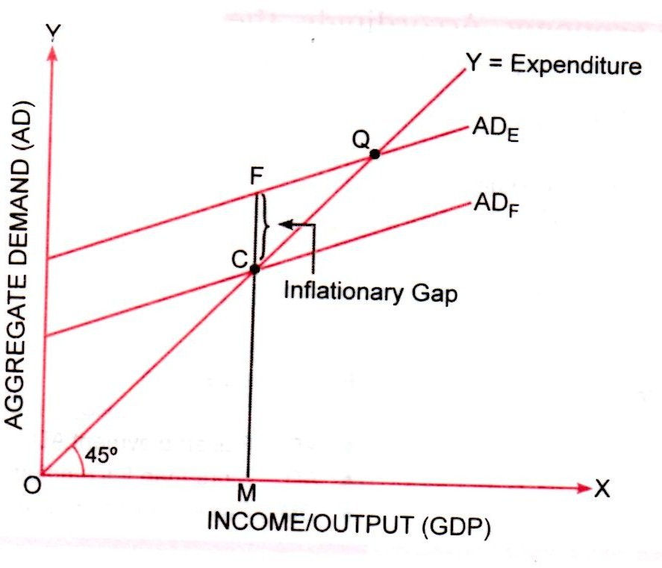  Inflationary gap = AD _{E} -- AD_{F} = CF. This is equal to excess demand.  AD _{E} : AD beyond full employment , AD_{F} : AD at full employment , OM* = full level of employment CF = inflationary gap. Point C shows full employment equilibrium level of output.AD beyond full employment cannot generate more output, it cause a pressure on the existing output. Consequently, prices will tend to rise. The economy faces a situation of inflation. Situation of excess demand is described as a situation of inflationary gap in the economy.  (2marks for explanation &1mark for diagram) |  |  | 6
 | Indian Economics - Section B
18. | b. |  |  | 1
19. | Production, productivity. |  |  | 1
20. | Disinvestment is an excellent tool for discarding the loss incurring Public Sector Enterprises |  |  | 1
21. | c |  |  | 1
22. | India’s share in world export is 2 % and share in world import is greater than 2%. |  |  | 1
23 | c |  |  | 1
24. | Tariff are a tax on imported goods- discourage their use. Non- tariffs are Quota barriers specify the quantity of goods that can be imported.  OR  Bilateral trade agreement is between 2 countries and Multilateral trade agreement between more than 2 countries. |  |  | 1
25. | Work force participation rate |  |  | 1
26. | (i) Availability of cheap labour (ii) growth of IT industry in India. |  |  | 1
27. | Ownership of land would give more incentive and increase output. |  |  | 1
28. | No, modernisation as a planning objective does not contradict employment generation. In fact, both modernisation and employment generation are positively correlated in the long-run. Modernisation refers to the use of new and modern technology in the production process.  For example, a farmer can increase the output on the farm by using new seed varieties instead of using the old ones ( or any other example)  The use of modern technology and input will raise productivity and consequently the income of the people, that will further raise the demand for goods and services. In order to fulfil this increased demand, more production output will be required and there will be more job opportunities, that will lead to higher employment in the economy. Even in the short run, modernisation leads to the creation of employment opportunities for skilled workers. If proper training and vocational education are provided, it will lead to better employment in terms of quality of work and earnings. The concept of modernisation is never contradictory to the employment generation activities, rather it has always worked towards changing the thinking of the people and society at large.  Hence, both modernisation and employment generation are not contradictory but are complementary to each other. |  |  | 3
29. | - In the 1990s, the absolute number of poor in rural areas had declined whereas the number of their urban counterparts increased marginally.  - The decline in poverty was comparatively much steep in rural areas where the percentage of people living below poverty line fell to about 25.7% in 2011-12 from 21.8 per cent (2004-05) and 56.4 in 1973-74. In urban areas, percentage of people living below poverty line fell from 49% to 21.7 per cent (2004-05) to 13.7 per cent (2011-12).  - The poverty ratio declined continuously for both urban and rural areas. The ratio is declining much slower than the absolute number of poor in the country. Also the gap between the absolute number of poor in rural and urban areas got reduced whereas in the case of ratio the gap has remained the same  This was because as people migrate from rural to urban areas, the poverty in rural areas seem to dip substantially, though the decline is more gradual in urban areas.  ( 1*3=3)  OR  Major reasons for poverty in India are :  (i) The low level of economic development under the British colonial administration. The policies of the colonial government ruined traditional handicrafts and discouraged the development of industries like textiles. The low rate of growth persisted until the 1980s. This resulted in fewer job opportunities and a low growth rate of incomes. This was accompanied by a high growth rate of the population. The two combined to make the growth rate of per capita income very low.  (ii) Lack of job opportunities: Lack of job opportunities compelled many people to work as rickshaw pullers, vendors, construction workers, domestic servants, etc. With irregular small incomes, these people could not afford expensive housing. They started living in slums on the outskirts of the cities.  (iii) Huge income inequalities: One of the major reasons for this is the unequal distribution of land and other resources. Major policy initiatives like land reforms that aimed at the redistribution of assets in rural areas have not been implemented properly by most of the state governments.  (iv) Lack of land resources has been one of the major causes of poverty in India.  (v) A high level of indebtedness among small farmers is also a major cause of poverty in our country. Since poor farmers hardly have any savings, they borrow. Unable to repay because of poverty, they become victims of indebtedness.  (1*3=3 marks) |  |  | 3
30 | (a)  1.No new industry was allowed unless a license was obtained from the government. This policy was used for promoting industry in backward regions. It was easier to obtain a license if the industrial unit was established in an economically backward area.  2. In addition, such units were given certain concessions such as tax benefits and electricity at a lower tariff. The purpose of this policy was to promote regional equality.  (2 marks)  (b)  The rationale of the import substitution strategy is based on infant industry argument.  It helped to save foreign exchange by drastically reducing import of goods. The foreign exchange saved was to be used for the developmental imports such as capital goods, sophisticated technology, etc. It created a protected market and large demand for domestically produced goods.  (2 marks) |  |  | 4
31. | (a)  1)The government provided loans at a low interest rate to small farmers and subsidized fertilizers so that small farmers could also have access to the needed inputs.  2) Since the small farmers could obtain the required inputs, the output on small farms equaled the output on large farms in the course of time.  3)The risk of the small farmers being ruined when pests attack their crops was considerably reduced by the services rendered by research institutes established by the government.  The green revolution would have favoured the rich farmers only if the state did not play an extensive role in ensuring that the small farmer also gains from the new technology. (3marks)  (b)  Due to Marketed surplus the prices of food grains declined relative to other items of consumption the low-income groups benefited from this decline. (1mark) |  |  | 4
32. | The health system in India has undoubtedly improved over the years but the pace of improvement has been unreasonably slow and truly we carry an unhealthy health system.  Following may be the most important concerns ailing Indian health system:  • Low Public Expenditure – In India the health expenditure as a  percentage of GDP is abysmally low as compared to some of the major  developing countries. It stood at around 4.7% of the total GDP in the year  2014-15.  • Urban Rural Divide – People living in rural India do not have sufficient  medical infrastructure. Nearly 70% of the population lives in rural areas  which have only 20% of the total hospitals of the country.  • Women and child health issues - More than 50 per cent of married  women in the age group of 15–49 years have iron deficiency, which has  contributed to maternal deaths. Infant Mortality Rate per 1,000 live births  in India is 34. Malnutrition and inadequate supply of vaccines lead to the  death of millions of children every year.  OR  Most people live in rural areas. The state of rural infrastructure in India is as follows:  - Rural women are still using biofuels such as crop residues, dung and fuel wood to meet their energy requirement.  - They walk long distances to fetch fuel, water and other basic needs.  - The census 2001 shows that in rural India only 56 per cent households have an electricity connection and 43 per cent still use kerosene. About 90 per cent of the rural households use biofuels for cooking.  - Tap water availability is limited to only 24 per cent of rural households. About 76 per cent of the population drinks water from open sources such as wells, tanks, ponds, lakes, rivers, canals, etc.  - Another study conducted by the National Sample Survey Organization noted that by 1996, access to improved sanitation in rural areas was only 6 per cent.  (Any 4. 1x4=4) |  |  | 4
33. | (a) critical assessment of the NEP policies  Any 3 negative and any 3 positive points  (3+3=6marks)  (b) Financial Sector Reforms-banking and non-banking financial institutions, stock exchange market and foreign exchange market.  Fiscal Reforms-related to revenue and expenditure reforms. (3+3=6marks) |  |  | 6
34. | (a) Now it is necessary to know how the growth pattern of employment and GDP affected different sections of workforce.  - Industrial sectors show substantial shift from farm work to non-farm work.  - In 1972-73, about 74 per cent of workforce was engaged in primary sector and in 2011-12, this proportion has declined to about 50 per cent.  - Secondary and service sectors are showing promising future for the Indian workforce. The shares of these sectors have increased from 11 to 24 per cent and 15 to 27 per cent, respectively.  - The distribution of workforce in different status indicates that over the last four decades (1972-2012), people have moved from self-employment and regular salaried employment to casual wage work.  5. Rural Urban breakup of male and female, Sectoral break up of male and female.  6. Self-employment continues to be the major employment provider. Scholars call the process of moving from self-employment and regular salaried employment to casual wage work as casualization of workforce.  (1*4 =4marks)  (b) Salaried employment, men are found to be so engaged in greater proportion. They form 20 per cent whereas women form only 13 per cent.  One of the reasons could be skill requirement. Since regular salaried jobs require skills and a higher level of literacy, women might not have been engaged to a great extent.  Family pressure. (2marks) |  |  | 6

xxxxxx

